Investigating the Impact of School Climate on Student Academic Achievement Using Hierarchical Linear Models

[Student Name Removed]

Teachers College Columbia University

Abstract

The purpose of this study is to isolate the independent effects of school climate on student academic achievement using a large, nationally representative U.S. database (Educational Longitudinal Survey; ELS, 2002) of student achievement and school climate. Previous studies about the relationship between school climate and students’ achievement usually heavily focus on the perception of students only. Besides, the effects sometimes are overestimated since the critical context variables and nested nature of education data are ignored. In this study, we apply the two-level hierarchical linear models and find significant but small effects of school climate on students’ academic achievement, controlling the critical context variable at both students and school level. Besides, we found that the impact of school climate is relatively more significant in from school administrators’ perception than students’ perception.

Keywords: School Climate, Surveillance, Academic Outcomes, Hierarchical Linear Models

Investigating the Impact of School Climate on Student Academic Achievement Using Hierarchical Linear Models

# Introduction

A perennial question posed in the literature of education practice is the extent to which the school climate may influence academic achievement and performance (Battistich, Solomon, Kim, Watson, & Schaps, 1995; Stewart, 2008; Kuperminc, Leadbeater, & Blatt, 2001; Marchant, Paulson, & Rothlisberg, 2001). Back to the 1900s, Perry (1908) examined the effects of principals in city schools on student learning, which is a specific starting point to explore the impact of school climate. Until the 1980s, more systematic analysis (e.g., Center for Social and Emotional Education, 2010) of school climate began. Since then, research has shown that school climate plays a critical role in terms of creating the sense of school community (Vieno, Perkins, Smith, & Santinello, 2005), motivating learner (Battistich, Solomon, Kim, Watson, & Schaps, 1995), facilitating student identity development (Rich & Schacter, 2012), reducing student dropout rates (Barile et al., 2012) and school violence (Leff, Power, & Costigan, 2003), and improving school satisfaction (Zullig, Koopman, Patton, & Ubbes, 2010), academic achievement (e.g., higher scores on standardized tests; Ghaith, 2003, MacNeil, Prater, & Busch, 2009). While previous studies have linked school climate to academic success and performance, many studies have fallen short in isolating the independent effects of school climate on student achievement using a large nationally representative sample.

This article provides greater clarity on how schools can focus on school climate to improve student learning and academic performance. We employed a two-level hierarchical linear model (HLM), nesting students within schools, and then estimated the direct effects of school climate (based on the perception of students and administrators) on longitudinal student achievement in mathematics during the last two years of high school. Using HLM, we can address many of the methodological issues of past research that focus on the question of the relationship between school climate and student achievement since more sophisticated controls and estimation procedures can be implied.

# Literature Review

Many empirical studies have investigated the school climate through an increasing number of potential indicators. (Benbenisty & Astor, 2005; Cohen, McCabe, Michelli, & Pickeral, 2009). Broadly, school climate for the student is based on the school environment, school order, safety, engagement, teacher mobility, racial tension, and many other factors (Kim, Schwartz, Cappella, & Seidman, 2014). Improving school climate is a challenging task since these factors are comprehensive and sometimes contradictory. For example, even though increasing policing of schools, metal detectors, and punitive disciplinary practices could help to make school safer, these actions have been found to diminish the overall climate of the school and do not deter the problematic behavior in school efficiently (Devine, 1996; Kupchik, 2010; Schreck, Miller, & Gibson 2003). Because the use of surveillance technologies and full-time law enforcement decreased relational trust within the school community (Bryk, Sebring, Allensworth, Luppescu, & Easton, 2010), clarity and fairness of rules (Gottfredson, Gottfredson, Payne, & Gottfredson, 2005). In the end, it affects student perceptions of safety, respect, and socio-emotional learning (McCoy, Roy, & Sirkman, 2013). It may also leads to higher dropout rates (Gonzalez, 2012).

Thapa, Cohen, Guffey, and Higgins D’Alessandro (2013) found a continued lack of well-defined and research-based models for school climate because fewer studies examined the effects of school climate within multilevel/hierarchical frameworks. There is a limited number of researches apply the hierarchical structure in their study of school climate. For example, Skiba and Williams (2014) found a significant association between school-level climate variables (e.g., principals’ perspectives on discipline and racial disparities in out-of-school suspension and expulsion). Meanwhile, Fan, Williams, and Corkin (2011) also constructed a multilevel analysis to examine the effects of social and academic risk factors on school climate. In their study, they found that individual-level behavioral and demographic predictors and school-level variables, such as school type (Catholic or Private), had a significant effect on students’ perceived climate (Fan, Williams, & Corkin, 2011). While both are essential studies of school climate, they failed to link the measurements of school climate to academic success. At the same time, the school climate usually is narrowly defined from the students’ perspective only. One of the breakthroughs in this study is to incorporate the administrator’s perception into the measurement of school climate.

Meanwhile, studies have emphasized the impact of the socioeconomics context of the community for the school (Lareau, 2003) and the demographic background (e.g., gender and race; Legewie & Diprete, 2012) on students’ academic achievement. However, many studies in modeling the influence of school climate on students’ academic performance failed to control these critical socioeconomic and demographics contexts at student level as well as school level. This may lead to inconsistent and even misleading findings (Davis & Warner, 2015). In this study, we include some essential context variables to adjust the independent effect of the school climate on students’ academic performance.

## Research Question

The research question of this study can be summarized as:

(1) to what extent, does students’ academic achievements vary across schools?

(2) to what extent, are the effects of students’ perception of school climate and their background on students’ achievement across different schools?

(3) to what extent, does school climate independently effect students’ achievement, controlling the students’ and schools’ context variables?

# Methods

## Data

## This study is a secondary analysis of the Education Longitudinal Study of 2002 (ELS:2002), which is collected by the National Center for Education Statistics (NCES). ELS:2002 Nationally representative, longitudinal study of 10th graders in 2002 and 12th graders in 2004. Approximate 16,100 students followed throughout secondary and postsecondary years. Multiple surveys are designed aiming at students, their parents, math and English teachers, and school administrators. Academic achievement for each student in the study are assessed in math (10th & 12th grades) and English (10th grade). In this study, we use the two assessments in mathematics for the sample of 161,00 students in Grade 10 in 2002 base year (BY) and Grade 12 in 2004 first follow-up (F1). After the listwise deletion, there are 9,891students within 361 high schools.

## Variables Included in the Analysis

Table 1 provides a descriptive statistic and labels and coding for the variables included in the model. The syntax of descriptive statistics is provided in the appendix.

**Dependent Variable**In this study, we focus on mathematics achievement as a representative indicator of students’ academic achievement. The standardized assessment score in mathematics for students in Grade 12 (FITXMSTD) is taken as the dependent variable in all models proposed in this study.

**School Climate Variable**In this study, two variables are used to indicate the school climate. At the student level (level 1), students’ perception of school safety (BYSCSAF2) is used. This variable is a scale of the students’ perceptions of base-year school safety. Higher values represent perceptions of greater school safety. The coefficient of reliability (Cronbach's alpha) for the scale is 0.64. At school level (level 2), administrators’ perception of academic climate (BYACCLIM) is used. This variable is a scale of the base-year school administrator’s perceptions of the school’s academic climate. Higher values represent perceptions of a more academically-oriented climate. To distinguish administrator-based scales from student-based scales, this variable was not standardized. The coefficient of reliability (Cronbach's alpha) for the scale is 0.86.

These two variables together measure the school climate from two different perspectives. These two variables were created through principal factor analysis weighted by sampling weight (i.e., Student final weight and school final weight for all base year responding students) and standardized to a mean of 0 and standard deviation of 1. Only respondents who provided a full set of responses were assigned a scale value. Even though many other indicators many also related to the measurement of school climate (as what we recognized in the limitation section of discussion), we only keep these two variables in the model for simplicity.

**Other Confounding/Controlling Variables** In this study, we also incorporated some controlling variable into the model to adjust the estimated effects of school climate. For the student level (level 1), we include students’ gender/sex (BYSCSAF2) and students’ standardized math test score in Grade 10 (i.e., pre-test; BYTXMSTD). For school level (level 2), we include school type (public, Catholic, or private; private as reference group) and school location (urban, suburban, or rural; rural as reference group). Among these controlling variables, students’ standardized math test score is the only continuous/scale variable. All the other variables are categorical/nominal variable, which will be incorporated into the model by dummy coding.

Table 1: Descriptive and ELS:2002 Labels and Coding for Variables in the Models

|  |  |  |  |  |  |  |
| --- | --- | --- | --- | --- | --- | --- |
| Variable | Mean | | SD | Min | Max | ELS:2002 Label |
| *Student Level* | | | | | | |
| Grade 12 Standardized Math Test Score | 51.11 | | 9.93 | 19.82 | 79.85 | FITXMSTD, (dependent variable for all models) |
| Grade 10 Standardized Math Test Score | 52.01 | | 9.72 | 20.49 | 86.68 | BYTXMSTD |
| Students’ Perception of School Safety | 0.23 | | 0.96 | -0.62 | 1.56 | BYSCSAF2 |
| Female | 0.5 | | 0.50 | 0 | 1 | BYSEX=2, coded 0 for males, 1 for females |
| *School Level* | | | | | | |
| Urban | 0.31 | | 0.46 | 0 | 1 | BYREGURB=1,4,7, or 10. Coded 0 or 1. Reference group is Rural. |
| Suburban | 0.49 | | 0.50 | 0 | 1 | BYURBAN =2,5,8, or 11. Coded 0 or 1. Reference group is Rural |
| Public | 0.76 | | 0.43 | 0 | 1 | BYREGCTL=1,4,7, or 10. Coded 0 or 1. Reference group is Private. |
| Catholic | 0.14 | | 0.35 | 0 | 1 | BYREGCTL=2,5,8, or 11. Coded 0 or 1. Reference group is Private. |
| Administrators’ Perception of Academic climate | 0.01 | | 0.16 | -0.63 | 0.27 | BYACCLIM |
| Student Sample Size | | 9891 | | | | | |
| High School Sample Size | | 520 | | | | |

Note: Approximate 39% cases have been deleted since missing or non-response.

## Data Preparation & Checking

To transform the data into the required format, a sequence of data preparation and checking steps are launched. The appendix provides the SPSS syntax for details. Firstly, the original data set for a viable school id is restricted. Consequently, we have to extract the first three digitals of the student ID to get the corresponding school ID. Secondly, Listwise deleting is applied for all variables in the model. In this method, an entire record is excluded from analysis if any single value is missing or non-response. About 39% of the case is removed in this step, which 5% threshold (Mertler and Vannatta, 2013) and indicate a considerable loss of the information in the study. Thanks to the large-scale data set, we still have about 9,800 cases available. This will not cause a big issue in the HLM model if the missing is completely at random. Otherwise, the listwise deletion may also lead to unignorable bias. Thirdly, all the categorical variables in the model are transformed by dummy coding, and all the continuous predictors are grand mean-centered. Finally, all the constant variables in the model fulfill the assumption of normality based on the evidence of the QQ plot (check Appendix for detail). There is no need for data transformation.

We calculate the Pearson correlation among the three continuous independent variables and the dependent variable (see Table 2). As we can see, there does not have a significant multicollinearity issue. And the correlation between the math test score in Grade 12 and Grade 10 is high, which matches our expectation of involving the pretest score into the model.

Table 2. Pearson Correlation Matrix for the continuous variables

|  |  |  |  |  |
| --- | --- | --- | --- | --- |
| Variables | Grade 12 Standardized Math Test Score | Grade 10 Standardized Math Test Score | Students’ Perception of School Safety | Administrators’ Perception of Academic climate |
| Grade 12 Standardized Math Test Score | 1.00 | 0.89 | 0.25 | 0.30 |
| Grade 10 Standardized Math Test Score | 0.89 | 1.00 | 0.26 | 0.23 |
| Students’ Perception of School Safety | 0.25 | 0.26 | 1.00 | 0.23 |
| Administrators’ Perception of Academic climate | 0.30 | 0.23 | 0.23 | 1.00 |

For the categorical variable, we create the contingency table to investigate the tendency (see Table 3). In general, students from private schools have a higher average score than Catholic and public schools. For school locations, students from suburban have a higher average score than rural and urban when the school is public and Catholic. For the private school, the students from urban have a higher score than suburban and rural. In the same type of school, male students have a higher score than females. However, the sample does not contain the case of rural Catholic schools. However, the difference and tendency we state above are not significant, given the standard deviation.

Table 3. Contingency Table for the average Math Test Score in Grade 12 across Conditions

|  |  |  |  |
| --- | --- | --- | --- |
| School Type | School Location | Gender | |
| Male | Female |
| Public | Urban | 49.4 (10.6) | 47.8 (9.7) |
| Suburban | 51.0 (10.4) | 50.0 (9.7) |
| Rural | 50.7 (9.9) | 49.3 (8.9) |
| Catholic | Urban | 55.0 (9.2) | 53.7 (8.4) |
| Suburban | 56.1 (7.9) | 53.0(8.2) |
| Rural | Na | Na |
| Private | Urban | 57.4 (9.7) | 56.0 (9.2) |
| Suburban | 55.6 (9.4) | 52.7 (7.9) |
| Rural | 53.9 (9.1) | 54.7 (7.2) |

Note: (1) the number in the bracket is standard deviation;

(2) there are no case for Catholic rural school.

## Models

In this study, a fixed-effects two-level hierarchical linear model is used to estimate the independent effects of school climate on student mathematic achievement. This model is recommended by many literatures of multi-level modeling (Hox 2002; Raudenbush and Bryk 2002) since it can capture the nature of student and school-level data, nesting students within schools. The variance in the dependent variable (mathematics scores) is decomposed into student-level and school-level variance components. The detail of HLM is beyond the scope of this paper. We recommend Hox (2002) to the reader for review.

In this model, we proposed three models. The three models are nested, which incorporate more variables step by step. For simplicity, there are no interaction effects, and all the slopes are defined as fixed effects with intercept is the only random effect. Model A is the null model. Model B is a single level (student level) model. Model C is the most complex one (two-level), which includes all the student-level and school-level variables.

**Model A: Null Model**

**Model B: Level 1 model (Student Level)**

**Model C: Level 2 model (School Level)**

, where is the dependent variable standardized assessment score in mathematics for students in Grade 12 (FITXMSTD) for the student in school , is the random intercept across schools, , , and are fixed effects for the independent variables at the student level, is the grand mean (intercept), , , , , and are the fixed effects for the independent variables at school level, is the residual error at school level and is the residual error at student level.

# Result

The detailed information about SPSS syntax and outputs has been provided in the Appendix. The summary of the model results is shown in Table 4. Model A (the null model) answers the first research question about “to what extent does students’ academic achievements vary across schools.” The estimated average (grand mean) score of the student achievement is about 50.90 (p < .001). The Wald Z (basically a one-way ANOVA analysis) of between-group variance is 10.69 (p < .001), which indicates that the intercepts vary significantly across schools. The intraclass correlation (ICC) is 17% (16.45 / (16.45+83.08)), which suggests that about 17 percent of the total variability in students’ academic achievement is determined between schools. Based on the empirical threshold of 5% (Heck et al., 2009) for ICC, the results indicated that a multilevel model analysis was warranted to determine the variability within and between schools.

Model B answers the second research question about “To what extent are the effects of students’ perception of school climate and their background information on students’ achievement across different schools.” The estimated average score of student achievement in Model B (50.94) is about the same value as Model A. All the student level independent variables are significantly based on the hypothesis of the t-test. The standardized coefficient is calculated by the formula:

Among all of these variables, pretest score (Grade 10 Standardized Math Test) has the biggest standardized effect (0.88; p < .001 ) on students’ achievement, which means a one-point improvement from the average pretest score is related to about a 0.88-point improvement in the Grade 12 standardized math test score when you hold other variables as constant. After standardization, the effect of students’ gender is -0.02, and students’ perception of the school climate (school safety) is 0.02. However, the estimation for students’ perception of school climate does have a higher significance level in the t-test than gender. Compared with model A, The Wald Z of between-group variance is decreased significantly from 10.69 to 6.76 (p < .001). Similarly, ICC for Model B is only about 3% (0.74 / (0.74+18.17)).

Model C answers the third research question “to what extent does school climate independently affect students’ achievement, controlling the student's and schools’ context variables.” All the estimated effects from students’ level independent variables and school-level variables, except the school type of Catholic, are significantly based on the hypothesis of t-tests. After standardizing the coefficient, the most considerable effect still comes from the pretest score in Grade 10. The impact of students’ perception of school climate is reduced to 0.01, which is smaller than the effects of the administrators’ perception of school climate (0.02). Among the school level variable, the most significant impact comes from the school type of public. The school location of urban and suburban have the same level of standardized impact. No matter for student-level or school level, we can see the independent effect from school climate is significant but limited after controlling other variables. The overall significance level is smaller for the school-level variables. Again, the Wald Z of between-group variance is decreased from 6.76 to 5.61 (p < .001). This can be partially explained by the low value of ICC, which is 0.03 (0.496 / (0.496+18.16)). This means a tiny proportion of total variance is explained by school level differences.

Table 4: Two-Level Hierarchical Models Estimating Grade 12 Math Standardized Test Score

|  |  |  |  |  |  |  |  |  |  |
| --- | --- | --- | --- | --- | --- | --- | --- | --- | --- |
| Variable | Model A | | | Model B | | | Model C | | |
| Unstandardized  Coefficient | Standardized  Coefficient | SE | Unstandardized  Coefficient | Standardized  Coefficient | SE | Unstandardized  Coefficient | Standardized  Coefficient | SE |
| Intercept |  | - | 0.24 |  | - | 0.07 | 51.48 | - | 0.31 |
| *Student Level* | | | | | | | | | |
| Grade 10 Standardized Math Test Score | - | - | - |  | 0.88 | 0.00 |  | 0.88 | 0.00 |
| Female | - | - | - |  | -0.02 | 0.09 |  | -0.02 | 0.08 |
| Perception of School Safety | - | - | - |  | 0.02 | 0.05 |  | 0.01 | 0.05 |
| *School Level* | | | | | | | | |  |
| Urban | - | - | - | - | - | - |  | 0.02 | 0.18 |
| Suburban | - | - | - | - | - | - |  | 0.02 | 0.16 |
| Public | - | - | - | - | - | - |  | -0.04 | 0.21 |
| Catholic | - | - | - | - | - | - |  |  | 0.25 |
| Perception of Academic climate | - | - | - | - | - | - |  | 0.02 | 0.34 |
| Intraclass Correlation | 0.17 | | | 0.03 | | | 0.03 | | |
| Deviance | 72418.50 | | | 57026.14 | | | 56958.10 | | |
| AIC | 72422.50 | | | 57030.14 | | | 56962.10 | | |
| BIC | 72436.90 | | | 57044.54 | | | 56976.49 | | |

Note: (1) *p<0.05, **p<0.01, ***p<0.001.

(2) Continuous variable has been grand mean centered.

# Discussion

## Implications

Our findings find a significant but small effect of school climate on students’ academic achievement from both students’ and school administrators’ perceptions. Surprisingly, the impact of administrators’ perception about school climate is slightly more significant than students’ perception. However, most of the previous study focuses heavily on students’ perceptions and sometimes ignore administrators’ effects.

Compared with other background information of student and school, the effect of perception about school climate is about the same level as gender, school location, and school type. The most significant impact comes from pretests score, which means students who have an excellent performance in Grade 10 are much more likely to keep performing well in Grade 12 no matter what background he/she has or how he/she feels about school climate. However, many previous researches fail to incorporate the pretest score when they analyzed the students’ performance. This may lead to overestimating the effects of student and schools’ background and school climate. Since the student level, independent variables (in particular pretest score) all have significant impacts and explain a large proportion of variance. This directly led to a low ICC value in Model B and Model C since the explanation power from school level independent variables is relatively small. However, we still keep the result of school level parameters since most of these effects, and even little, are still significant. Besides, these variables play an essential role in understanding what role the school climate will play under different school conditions. Thus, it is ignorable in the interpretation perspective instead of a statistics perspective.

**Limitations**

There are three main limitations to this study. Firstly, the data set and variables that we used in the analysis are focus on narrow definitions of school (high school), student achievement, school climate, and other controlling variables. For simplicity, this study only incorporated 3 to 4 controlling variables at each level. Consequently, many unignorable variables many be excluded. For student level, students’ race background, whether they were from a non-traditionally family, whether they had transferred during the period of BY and F1, social-economics status (SES), and students’ perception of the importance of mathematics may play a critical effect on their achievements. These variables have been widely used in many other educational researches and proved to be significantly related to students’ academic performance (e.g., standard assessment of mathematics skills). For the school level, variables like school size (e.g., small enrollment, median enrollment, large enrollment, or extra-large enrollment), student-teacher ratio, percentage of free lunch students, and percentage of minority students may provide a much more comprehensive description of school beyond school type and school location. Future studies could include more confounding variables, which have been suggested by previous studies or evidence from education practices, into the model so that we can reduce the ignorable systematic bias in the HLM model. Besides, the variables that we selected to indicate school climate may not be representative and comprehensive enough. This study does not incorporate other indicators or create a composite index for the overall school climate. This, to some extent, could lead to the internal validity issue. Similar issues can also be found independent variables about academic achievement. Standardized assessment scores in mathematics, to some extent, represent an objective measurement of student’s performance. However, students’ performances are not necessary for the same or even similar across different subjects. A better approach may be incorporated as a composite indicator of academic achievement, which is based on both mathematics and reading together. Or, two separate models could be analyzed for mathematics and reading individually.

Secondly, the sampling strategy for ELS:2002 is ignored in this study for simplicity. EL：2002 used a complicated probabilistic sampling procedure to allow for generalizations to all 3.8 million students in the U.S. who were in grade 10 in 2002 (Ingles et al. 2004). However, MLM assumes a simple random sample. A normalized weighting procedure, instead of the unweighted data, should be used to adjust the estimates and standard error to reflect better the sampling procedure and each case’s representativeness in the population.

Finally, there are some limitations in terms of data preparation. The listwise delectation is used in this study, which leads to a 39% loss of cases in the study. A better solution will be using multiple imputation or other data imputation techniques to generate a plausible variable for all the missing data. Besides, we cannot guarantee whether the absence in the data set is completely at random. Listwise deletion may lead to bias estimation. Secondly, the outliers are not handled in this study. Future studies could use Mahalanobis distance, which is widely used in multivariate regression for identifying the potential outliers. The ELS:2002 has been proved to be a reliable data source under a strict data collection process. Consequently, troughing out a large number of outliers may lead to an ignorable loss of information. If the number of outliers is not significant, on the other hand, then it will not affect the analysis severely given the large-scale data set.

References

Barile, J., Donohue, D., Anthony, E., Baker, A., Weaver, S., & Henrich, C. (2012). Teacher-

student relationship climate and school outcomes: Implications for educational policy initiatives. *Journal of Youth & Adolescence*, 41(3), 256-267.

Battistich, V., Solomon, D., Kim, D., Watson, M., & Schaps, E. (1995). Schools as communities,

poverty levels of student populations, and students’ attitudes, motives, and performance: A multilevel analysis. *American Educational Research Journal*, 32(3), 627-658.

Bellmore, A., Nishina, A., You, J., & Ma, T. (2012). School context protective factors against

peer ethnic discrimination across the high school years. *American Journal of Community Psychology*, 49(1-2): 98-111.

Bryk, A. S., Sebring, P. B., Allensworth, E., Luppescu, S., & Easton, J. Q. (2010). *Organizing*

*schools for improvement: Lessons from Chicago*. Chicago: University of Chicago.

Cohen, J., McCabe, E., Michelli, N., & Pickeral, T. (2009). School climate: Research, policy,

practice, and teacher education. *Teachers College Record*, 111(1), 180–213.

Collie, R. J., Shapka, J. D., & Perry, N. E. (2011). Predicting teacher commitment: The impact of

school climate and social-emotional learning. *Psychology in the Schools*, 48(10), 1034-

1048.

Fan, W., Williams, C. M. & Corkin, D. M. (2011). A multilevel analysis of student perceptions of

school climate: The effect of social and academic risk factors. *Psychology in the Schools*,

48(6), 632–647.

Gonzalez, T. (2012). Keeping kids in schools: Restorative justice, punitive discipline, and the

school to prison pipeline. *Journal of Law and Education*, 41(1), 281-335.

Gottfredson, G. D., Gottfredson, D. C., Payne, A. A., & Gottfredson, N. C. (2005). School

climate predictors of school disorder: Results from a national study of delinquency

prevention in schools. *Journal of Research in Crime and Delinquency*, 42(4), 412-444.

Heck, R. H., Thomas, S. L., & Tabata, L. N. (2013). *Multilevel and Longitudinal Modeling*

*with IBM SPSS* (2nd ed.). New York, NY: Routledge. 978-0415817110

Hedges, L.V., Laine, R. D., & Greenwald, R. (1994). An exchange: Part I: Does money matter?

A meta-analysis of studies of the effects of differential school inputs on student outcomes. *Educational Researcher*, 23(3), 5-14.

Hirschfield, P. J. (2008). Preparing for prison? The criminalization of school discipline in the

USA. *Theoretical Criminology*, 12(1), 79-101.

Hoffman, S. (2014). Zero benefit: Estimating the effect of zero tolerance discipline policies on

racial disparities in school discipline. *Educational Policy*, 28(1), 69-95.

Hursh, D. (2007). Assessing No Child Left Behind and the rise of neoliberal education policies.

*American Education Research Journal*, 44(3), 493-518.

Jain, S., Cohen, A. K., Huang, K., Hanson, T. L., & Austin, G. (2015). Inequalities in school

climate in California. *Journal of Educational Administration*, 53(2), 237-261.

Kim, H.Y., Schwartz, K., Cappella, E., & Seidman, E. (2014). Navigating middle grades: Role of

social contexts in middle grade school climate. *American Journal of Community*

*Psychology*, 54(1-2), 28-45.

Kuperminc, G. P., Leadbeater, B. J., & Blatt, S. J. (2001). School social climate and individual

differences in vulnerability to psychopathology among middle school students. *Journal of School Psychology*, 39(2), 141-159.

Leff, S. S., Power, T. J., & Costigan, T. E. (2003). Assessing the climate of the playground and

lunchroom: Implications for bullying prevention programming. *School Psychology*

*Review,* 32(3), 418-430.

Legewie, J., & Diprete, T.A. (2012). School context and the gender gap in educational

achievement. *American Sociological Review*, 77(3), 463-485.  
Luke, D. A. (2004). *Multilevel modeling*. Thousand Oaks, CA: Sage Publications.

Mertler & Vannatta Reinhart (2017) *Advanced and Multivariate Statistical Methods*, Sixth

Edition, Routledge, ISBN: 978-1138289734.

Peterson, R. L., & Skiba, R. (2001). Creating school climates that prevent school violence. *The*

*Social Studies*, 92(4), 167-175.  
Raudenbush, S. W., & Bryk, A. S. (2002) *Hierarchical linear models: Applications and data*

*analysis methods* (2nd ed.). Thousand Oaks, CA: Sage Publications.  
Rich, Y., & Schachter, E. P. (2012). High school identity climate and student identity

development. *Contemporary Educational Psychology*, 37(3), 218-228.  
Ripski, M. B., & Gregory, A. (2009). Unfair, unsafe, and unwelcome: Do high school students’

perceptions of unfairness, hostility, and victimization in school predict engagement and

achievement? *Journal of School Violence*, 8, 355-375.

Schreck, C. J., Miller, J. M., & Gibson, C. L. (2003). Trouble in the school yard: A study of risk

factors of victimization at school. *Crime and Delinquency*, 49(3): 460-484.

Skiba, R. J., Chung, C., Trachok, M., Baker, T. L., Sheya, A., & Hughes, R. L. (2014). Parsing

disciplinary disproportionality: Contributions of infraction, student, and school

characteristics to out-of-school suspension and expulsion. *American Educational Research Journal*, 51(4), 640-670.

Stewart, E. B. (2008). School structural characteristics, student effort, peer associations, and

parental involvement: The influence of school- and individual-level factors on academic achievement. *Education and Urban Society*, 40(2), 179-204.

Thapa, A., Cohen, J., Guffey, S., & Higgins-D’Alessandro, A. (2013). A review of school climate

research. *Review of Educational Research*, 83(3), 357-385.

Thapa, A., Cohen, J., Higgins-D’Alessandro, A., & Guffey, S. (2012). *School climate research*

*study*: August 2012. National School Climate Center, 3.

Tuzzolo, E., & Hewitt, D. T. (2006). Rebuilding inequality: The re-emergence of the school-to-

prison pipeline in New Orleans. *The High School Journal*, 90(2), 59-68.

Vieno, A., Perkins, D., Smith, T., & Santinello, M. (2005). Democratic school climate and sense

of community in school: A multilevel analysis. *American Journal of Community  
Psychology*, 36(3-4), 327-341.

Welch, K., & Payne, A. A. (2010). Racial threat and punitive school discipline. Social Problems,

57(1), 25-48.

Zullig, K., Koopman, T., Patton, J., & Ubbes, V. (2010). School climate: Historical review,

instrument development, and school assessment. *Journal of Psychoeducational*

*Assessment*, 28(2), 139 – 152.

**Appendix**

## Data Preparation

## Create School ID from Student ID

ALTER TYPE STU_ID (A8).  
EXECUTE.  
COMPUTE SCH = NUMBER (CHAR.SUBSTR(STU_ID,2,6), f4) .  
EXECUTE .  
ALTER TYPE STU_ID (F8).

## Listwise Delete the Missing or Non-response Cases

USE ALL.  
COMPUTE filter_$=(BYSEX >= 0  & BYTXMSTD >= 0 & BYREGURB >= 0 & BYREGCTL >= 0 & BYSCSAF2 >= -3 &  
    BYACCLIM >= -3 & F1TXMSTD >= 0 & STU_ID >= 0 & SCH >= 0).  
VARIABLE LABELS filter_$ 'BYSEX >= 0  & BYTXMSTD >= 0 & BYREGURB >= 0 & BYREGCTL >= 0 & BYSCSAF2 '+  
    '>= -3 & BYACCLIM >= -3 & F1TXMSTD >= 0 & STU_ID >= 0 & SCH >= 0 (FILTER)'.  
VALUE LABELS filter_$ 0 'Not Selected' 1 'Selected'.  
FORMATS filter_$ (f1.0).  
FILTER BY filter_$.  
EXECUTE.

## Create the New Variable of School Location and School Type

RECODE BYREGURB (1=1) (4=1) (7=1) (10=1) (2=0) (3=0) (5=0) (6=0) (8=0) (9=0) (11=0) (12=0) INTO

Urban.

EXECUTE.

RECODE BYREGURB (3=0) (6=0) (9=0) (12=0) (1=0) (4=0) (7=0) (10=0) (2=1) (5=1) (8=1) (11=1) INTO

Suburban.

EXECUTE.

RECODE BYREGCTL (3=0) (6=0) (9=0) (12=0) (1=0) (4=0) (7=0) (10=0) (2=1) (5=1) (8=1) (11=1) INTO

Catholic.

EXECUTE.

RECODE BYREGCTL (3=0) (6=0) (9=0) (12=0) (2=0) (5=0) (8=0) (11=0) (1=1) (4=1) (7=1) (10=1) INTO

Public.

EXECUTE.

## Change the Code of Variable BYSEX into 0 or 1.

RECODE BYSEX (1=0) (2=1).  
EXECUTE.

## Grand Mean Centering for the Continuous Predictors

COMPUTE center_student=BYSCSAF2 - 0.231692.  
EXECUTE.  
COMPUTE center_admin=BYACCLIM - 0.012817.  
EXECUTE.  
  COMPUTE center_pretest=BYTXMSTD - 52.011513.

EXECUTE.

## QQ Plots

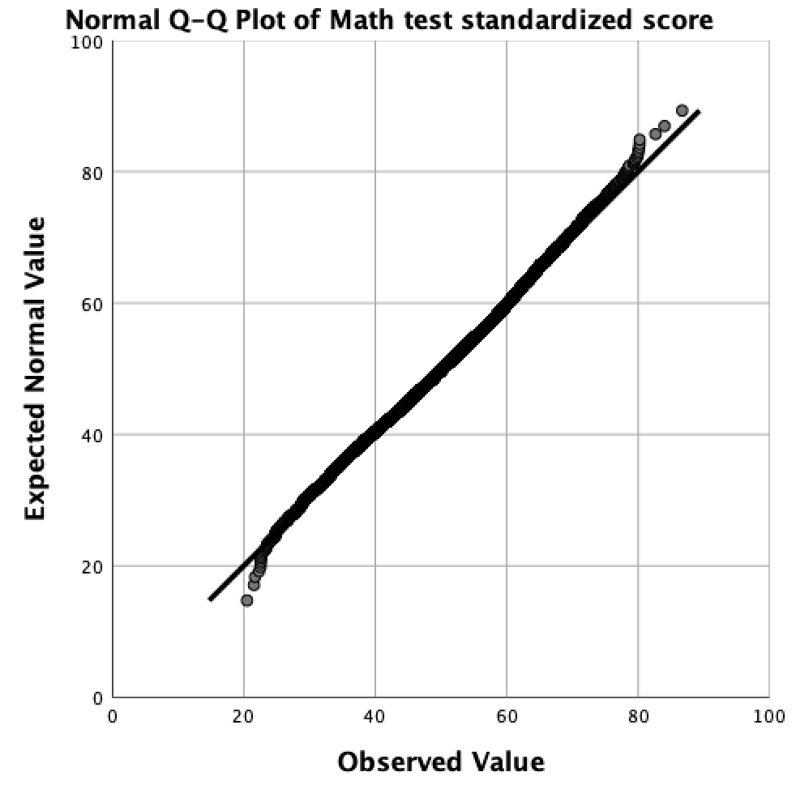PPLOT  
  /VARIABLES=BYTXMSTD BYSCSAF2 BYACCLIM F1TXMSTD  
  /NOLOG  
  /NOSTANDARDIZE  
  /TYPE=Q-Q  
  /FRACTION=BLOM  
  /TIES=MEAN  
  /DIST=NORMAL.

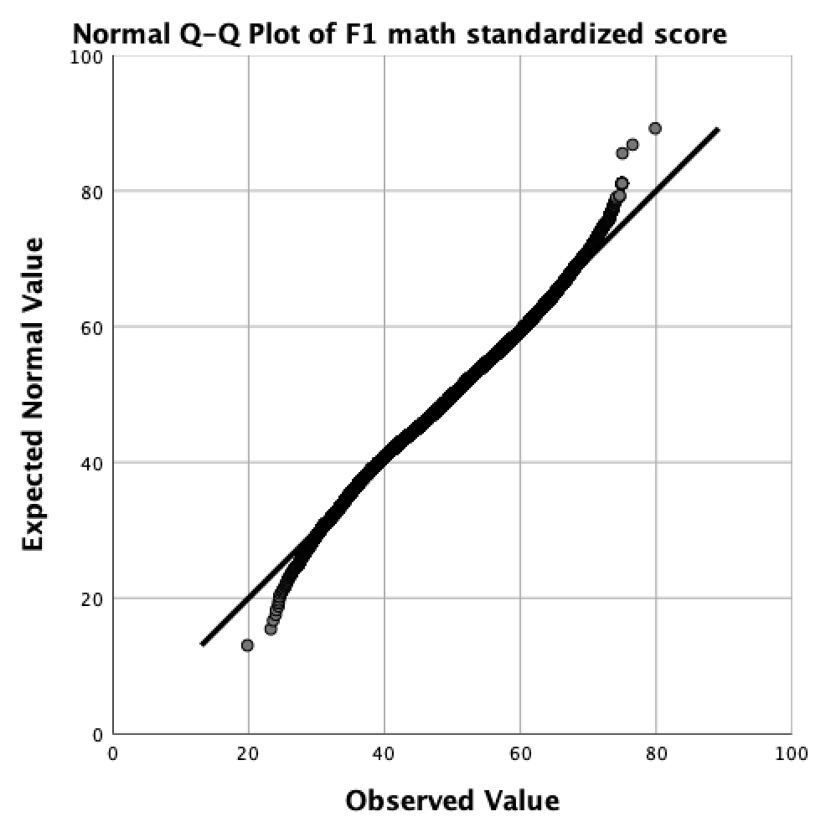  
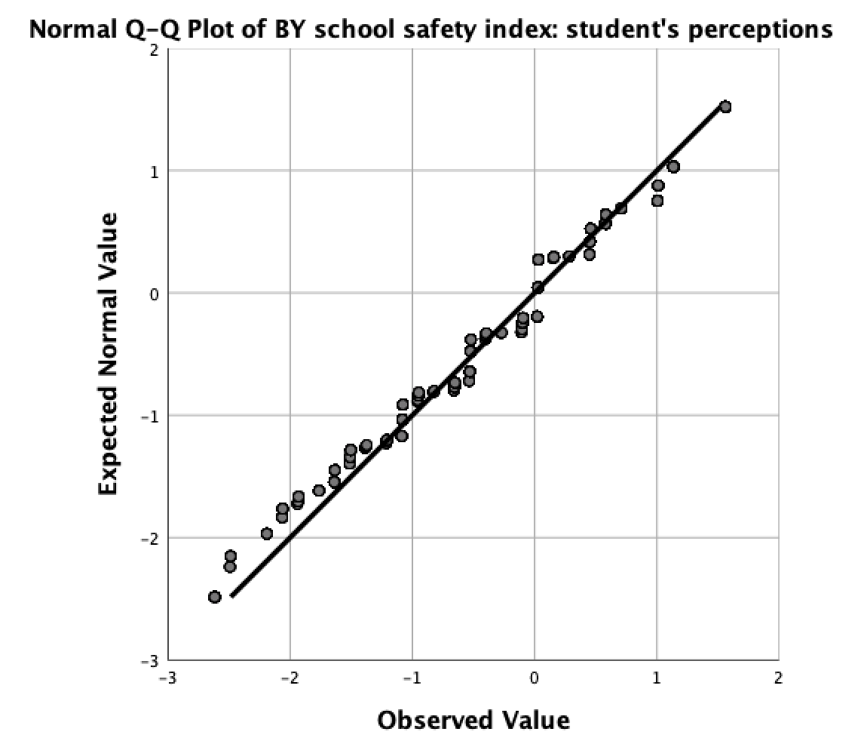

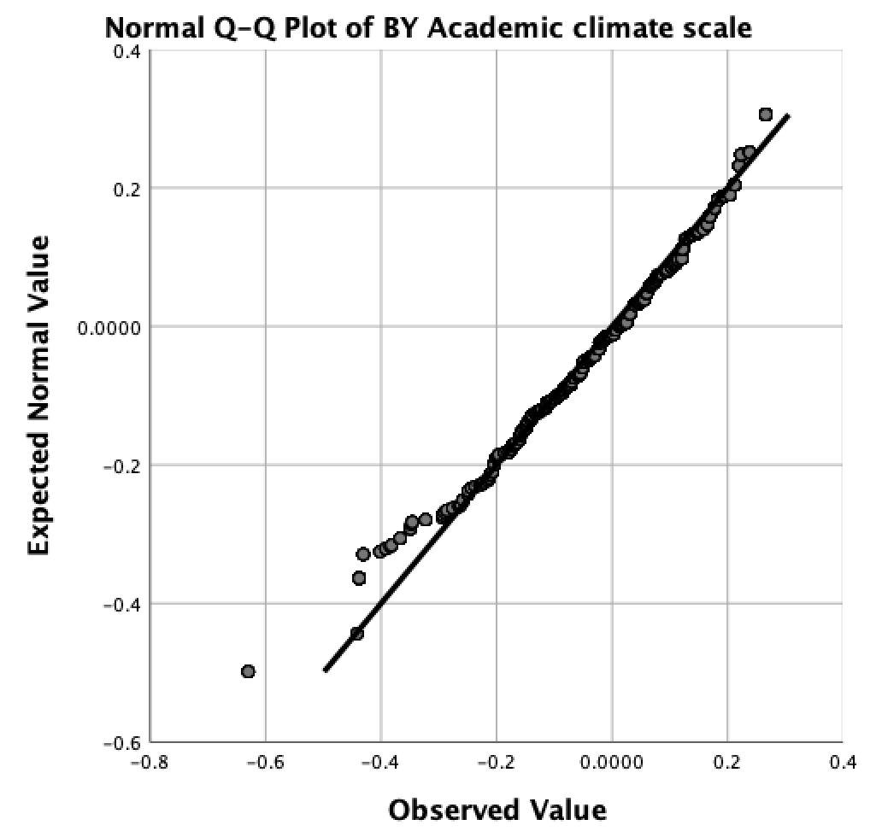

## Data Description (Table 1)

## Descriptive Statistics

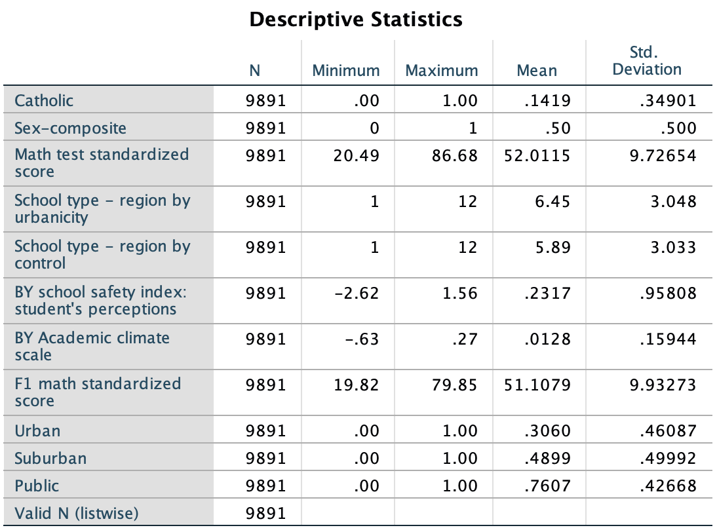DESCRIPTIVES VARIABLES=Catholic BYSEX BYTXMSTD BYREGURB BYREGCTL BYSCSAF2 BYACCLIM F1TXMSTD Urban  
    Suburban Public  
  /STATISTICS=MEAN STDDEV MIN MAX.

## Correlations among the continuous variables (Table 2)

CORRELATIONS  
  /VARIABLES=BYTXMSTD BYSCSAF2 BYACCLIM F1TXMSTD  
  /PRINT=TWOTAIL SIG  
  /MISSING=LISTWISE.

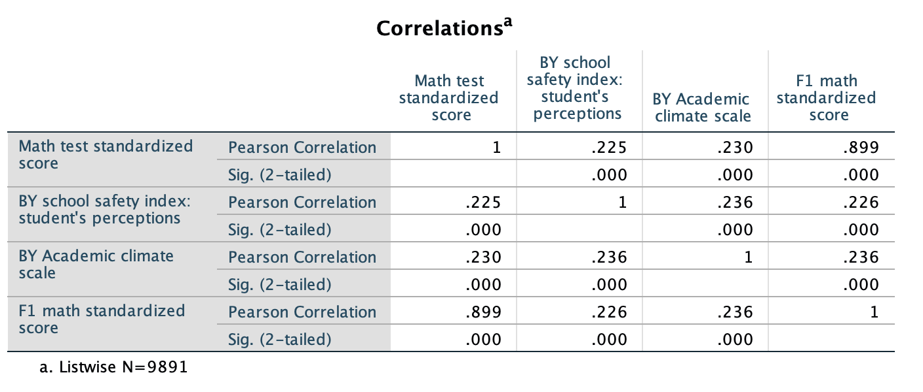

## Contingency Table (Table 3; in R)

library(readxl)

library(dplyr)

contingency <- read_excel("contingency.xlsx")

contingency %>% filter(Urban==1,Suburban==0,Public==1,Catholic==0,BYSEX==0) %>% summarise(std = sd(F1TXMSTD),avg = mean(F1TXMSTD))

contingency %>% filter(Urban==1,Suburban==0,Public==1,Catholic==0,BYSEX==1) %>% summarise(std = sd(F1TXMSTD),avg = mean(F1TXMSTD))

contingency %>% filter(Urban==0,Suburban==1,Public==1,Catholic==0,BYSEX==0) %>% summarise(std = sd(F1TXMSTD),avg = mean(F1TXMSTD))

contingency %>% filter(Urban==0,Suburban==1,Public==1,Catholic==0,BYSEX==1) %>% summarise(std = sd(F1TXMSTD),avg = mean(F1TXMSTD))

contingency %>% filter(Urban==0,Suburban==0,Public==1,Catholic==0,BYSEX==0) %>% summarise(std = sd(F1TXMSTD),avg = mean(F1TXMSTD))

contingency %>% filter(Urban==0,Suburban==0,Public==1,Catholic==0,BYSEX==1) %>% summarise(std = sd(F1TXMSTD),avg = mean(F1TXMSTD))

contingency %>% filter(Urban==1,Suburban==0,Public==0,Catholic==1,BYSEX==0) %>% summarise(std = sd(F1TXMSTD),avg = mean(F1TXMSTD))

contingency %>% filter(Urban==1,Suburban==0,Public==0,Catholic==1,BYSEX==1) %>% summarise(std = sd(F1TXMSTD),avg = mean(F1TXMSTD))

contingency %>% filter(Urban==0,Suburban==1,Public==0,Catholic==1,BYSEX==0) %>% summarise(std = sd(F1TXMSTD),avg = mean(F1TXMSTD))

contingency %>% filter(Urban==0,Suburban==1,Public==0,Catholic==1,BYSEX==1) %>% summarise(std = sd(F1TXMSTD),avg = mean(F1TXMSTD))

contingency %>% filter(Urban==0,Suburban==0,Public==0,Catholic==1,BYSEX==0) %>% summarise(std = sd(F1TXMSTD),avg = mean(F1TXMSTD))

contingency %>% filter(Urban==0,Suburban==0,Public==0,Catholic==1,BYSEX==1) %>% summarise(std = sd(F1TXMSTD),avg = mean(F1TXMSTD))

contingency %>% filter(Urban==1,Suburban==0,Public==0,Catholic==0,BYSEX==0) %>% summarise(std = sd(F1TXMSTD),avg = mean(F1TXMSTD))

contingency %>% filter(Urban==1,Suburban==0,Public==0,Catholic==0,BYSEX==1) %>% summarise(std = sd(F1TXMSTD),avg = mean(F1TXMSTD))

contingency %>% filter(Urban==0,Suburban==1,Public==0,Catholic==0,BYSEX==0) %>% summarise(std = sd(F1TXMSTD),avg = mean(F1TXMSTD))

contingency %>% filter(Urban==0,Suburban==1,Public==0,Catholic==0,BYSEX==1) %>% summarise(std = sd(F1TXMSTD),avg = mean(F1TXMSTD))

contingency %>% filter(Urban==0,Suburban==0,Public==0,Catholic==0,BYSEX==0) %>% summarise(std = sd(F1TXMSTD),avg = mean(F1TXMSTD))

contingency %>% filter(Urban==0,Suburban==0,Public==0,Catholic==0,BYSEX==1) %>% summarise(std = sd(F1TXMSTD),avg = mean(F1TXMSTD))

1. **Modeling**

* **The Null Model (Model A)**

MIXED F1TXMSTD

/CRITERIA=DFMETHOD(SATTERTHWAITE) CIN(95) MXITER(100) MXSTEP(10) SCORING(1)

SINGULAR(0.000000000001) HCONVERGE(0, ABSOLUTE) LCONVERGE(0, ABSOLUTE) PCONVERGE(0.000001, ABSOLUTE)

/FIXED=| SSTYPE(3)

/METHOD=REML

/PRINT=G SOLUTION TESTCOV

/RANDOM=INTERCEPT | SUBJECT(SCH) COVTYPE(VC).

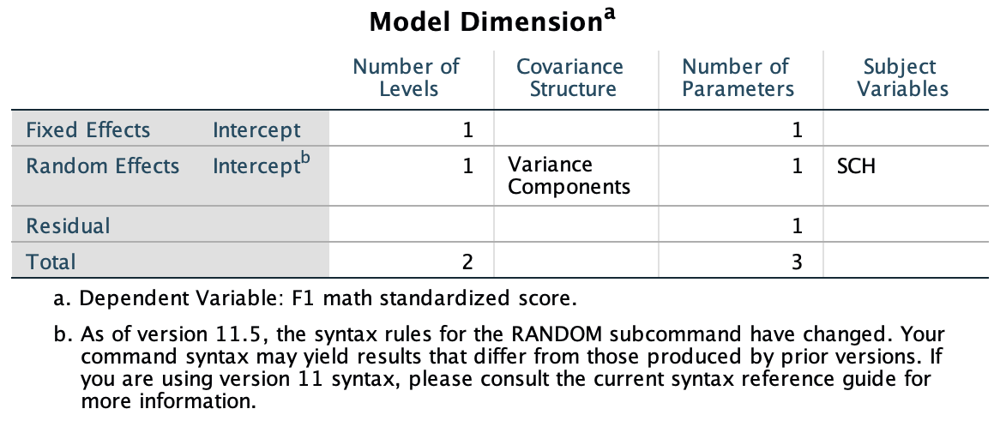

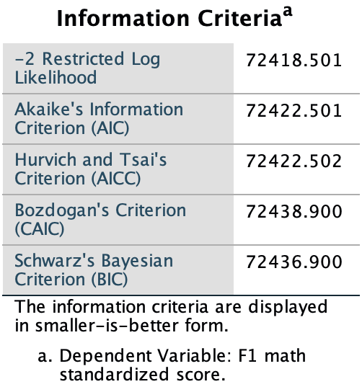

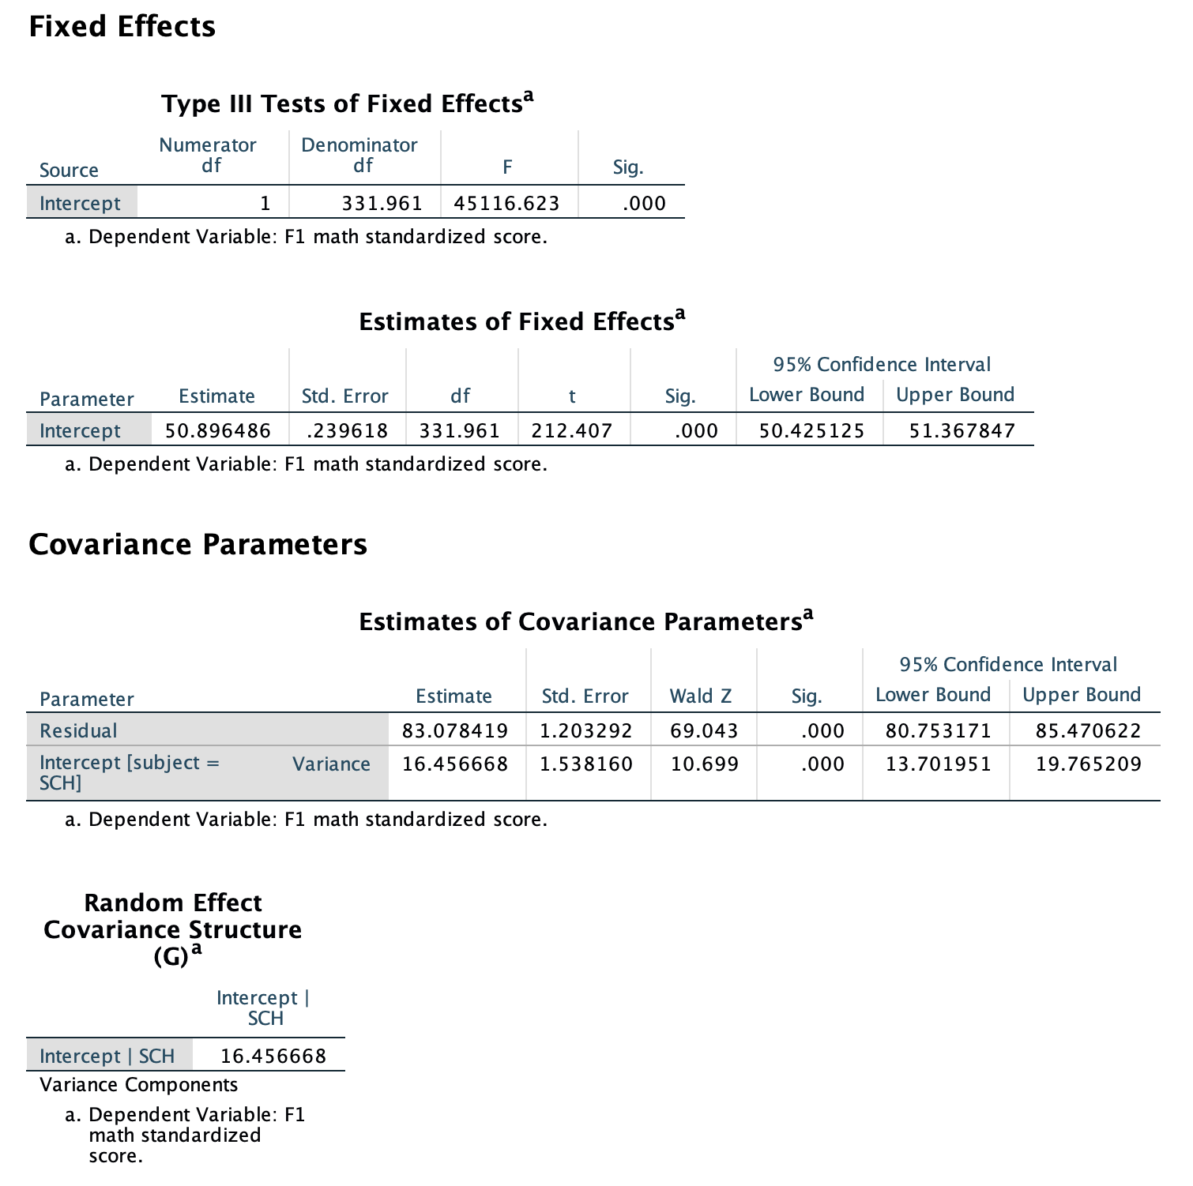

* **Level one model (Model B)**

MIXED F1TXMSTD WITH center_student center_pretest BYSEX  
  /CRITERIA=DFMETHOD(SATTERTHWAITE) CIN(95) MXITER(100) MXSTEP(10) SCORING(1) SINGULAR(0.000000001)  
    HCONVERGE(0, ABSOLUTE) LCONVERGE(0, ABSOLUTE) PCONVERGE(0.000001, ABSOLUTE)  
  /FIXED=center_student center_pretest BYSEX | SSTYPE(3)  
  /METHOD=REML  
  /PRINT=G  SOLUTION TESTCOV  
  /RANDOM=INTERCEPT | SUBJECT(SCH) COVTYPE(VC).

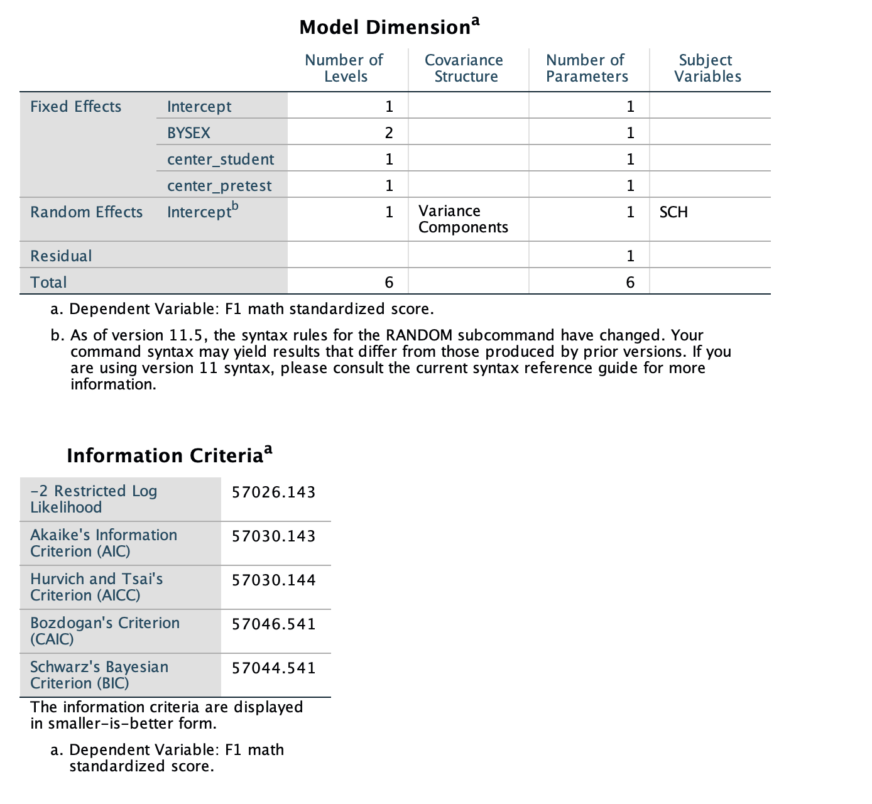

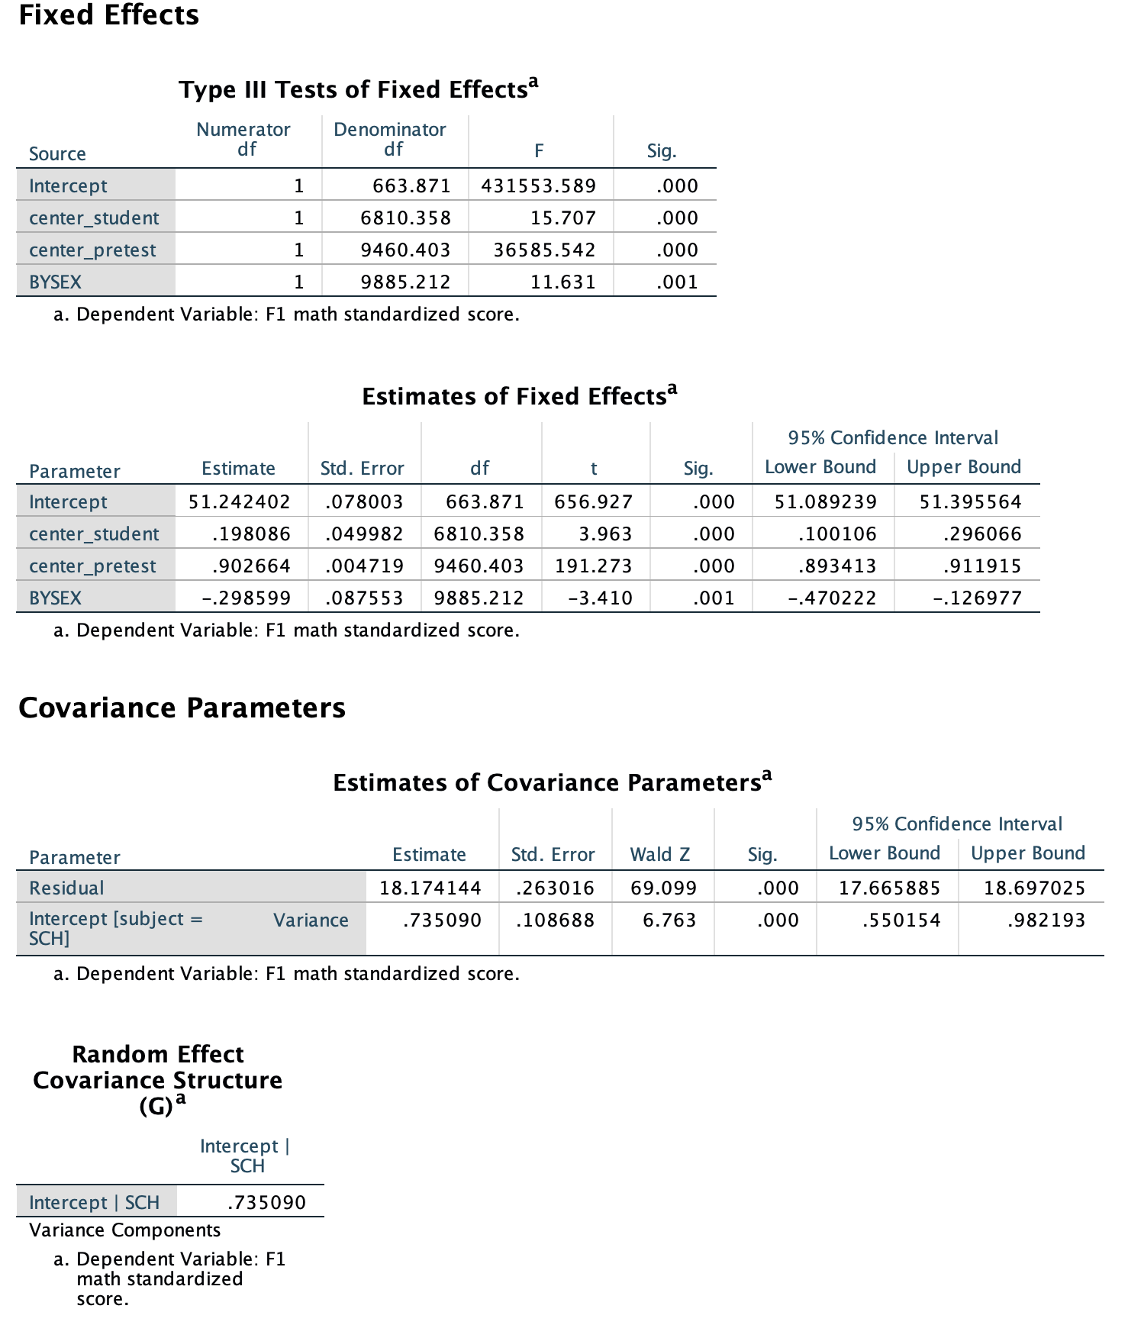

* **Level one model (Model C)**

MIXED F1TXMSTD WITH center_student center_pretest center_admin BYSEX Urban Suburban Catholic Public

/CRITERIA=DFMETHOD(SATTERTHWAITE) CIN(95) MXITER(100) MXSTEP(10) SCORING(1) SINGULAR(0.000000001)

HCONVERGE(0, ABSOLUTE) LCONVERGE(0, ABSOLUTE) PCONVERGE(0.000001, ABSOLUTE)

/FIXED=center_student center_pretest center_admin BYSEX Urban Suburban Catholic Public | SSTYPE(3)

/METHOD=REML

/PRINT=G SOLUTION TESTCOV

/RANDOM=INTERCEPT | SUBJECT(SCH) COVTYPE(VC).

